Infrastructure Planning with Zerto Analytics

As of Zerto 7.0u1, users can leverage the Planner tool within Zerto Analytics to size environments, forecast consumption, and plan ahead for infrastructure needs. VMs *do not* need to be protected by Zerto yet in order for Zerto Analytics to track IO and making sizing recommendations.

Instructions:

1. Download the Zerto Virtual Manager (ZVM) installer, version 7.0 update 1 or above, from [myzerto.com](http://www.myzerto.com)
2. Install the ZVM on a Windows VM:
   * Either Express or Custom Installation will work
   * vCenter admin credentials need to be provided
   * Online services should be left *enabled* (default). This secure, one-way data transmission is *required* for Zerto Analytics and the Planner tool.  
     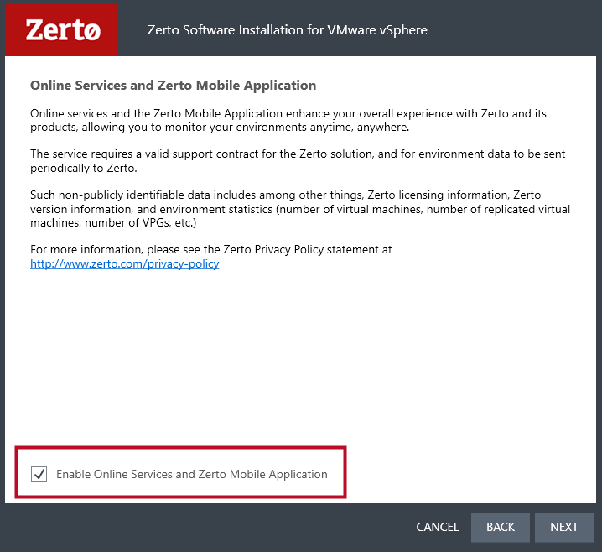
3. Set up the ZVM by logging in and licensing using a trial key (prospects), NFR key (resellers), or cloud key (CSPs), or by pairing to an already licensed site.
4. From within the ZVM GUI, click on “Analytics” from the left-hand navigation menu *or* go directly to [analytics.zerto.com](https://analytics.zerto.com); allow at least 12 hours for data to fully populate.
5. Log in to Zerto Analytics and navigate to the "Planning" tab. Once there, click the blue button labeled “VM Selection”, seen below:

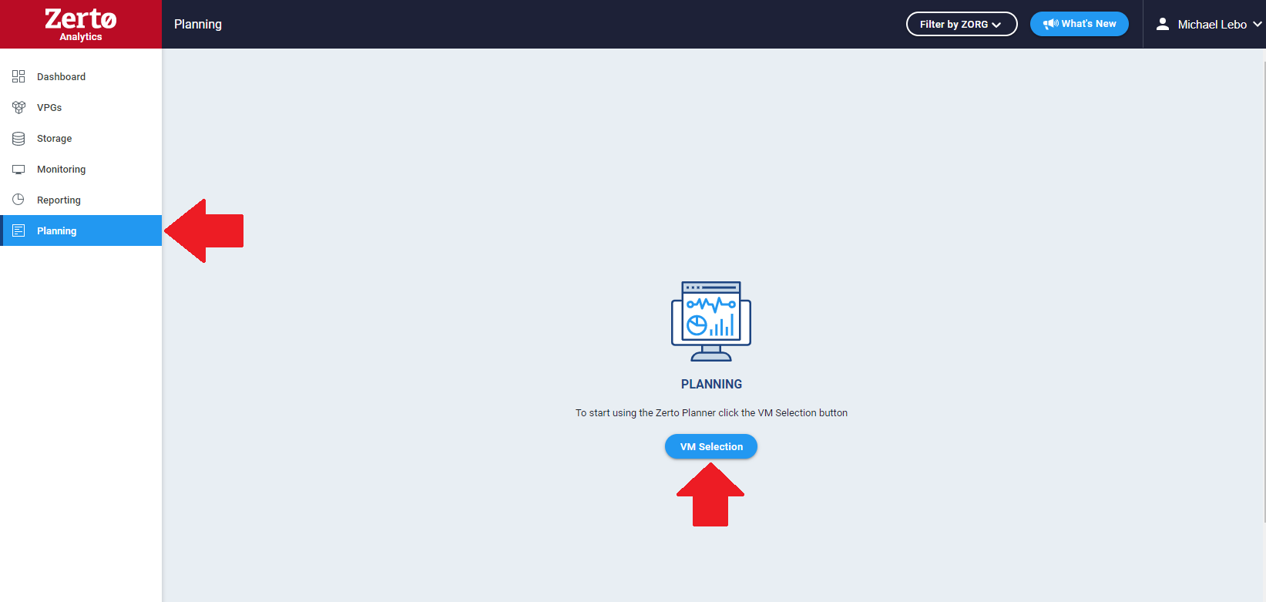

1. A new VM selection screen will pop-up within Zerto Analytics. Once there, you will:
   * Select the source site
   * Select the target platform (Azure, AWS, CSP partner, or on-premises with vSphere or Hyper-V)
   * Select the VMs that you wish to monitor from the left-hand panel. Use the arrows located in the center of the window to move the VMs to the right-hand panel. Only these selected VMs will be monitored. Once completed, click the blue Save button in the bottom-right corner:

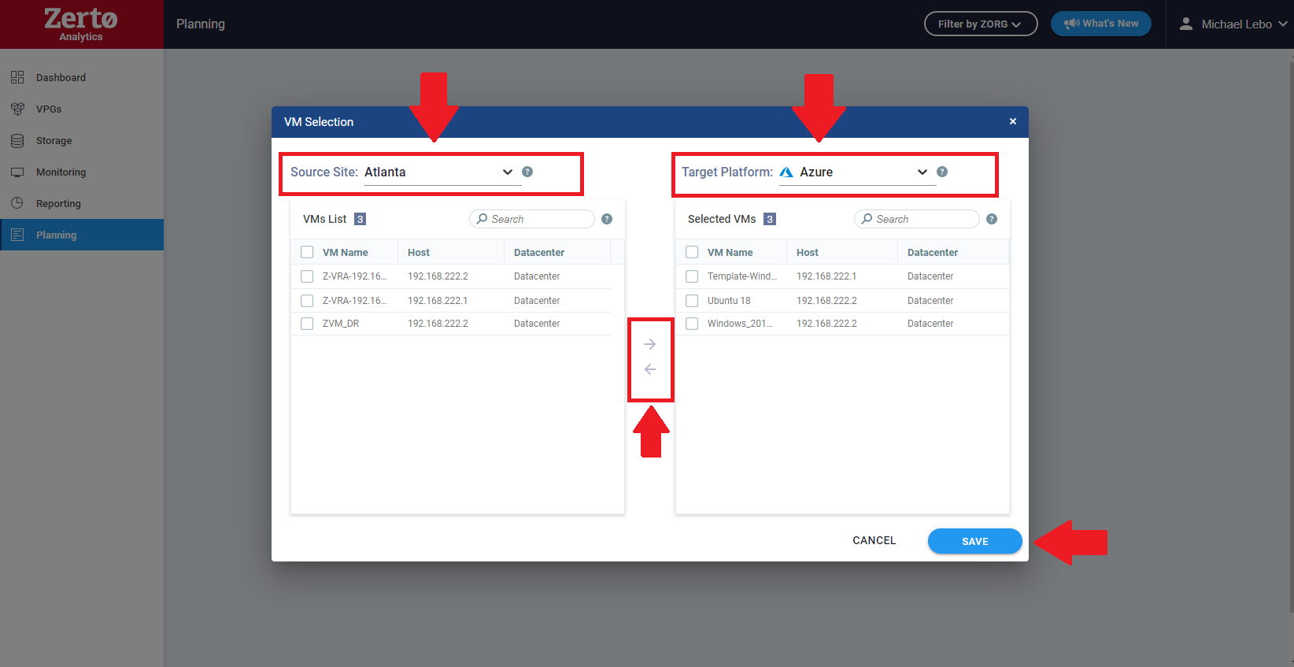

1. Once saved, the Planner will direct you to the generated report. Allow the Planner to monitor the VMs for an extended period by simply leaving the ZVM online for the desired timeframe (hours, days, or weeks). This will give a more accurate aggregate of the data for the Planner’s recommendations. Planner will collect data on all VMs while the ZVM is online so that no new data collection needs to occur if selecting different VMs or different dates to display in Zerto Analytics.

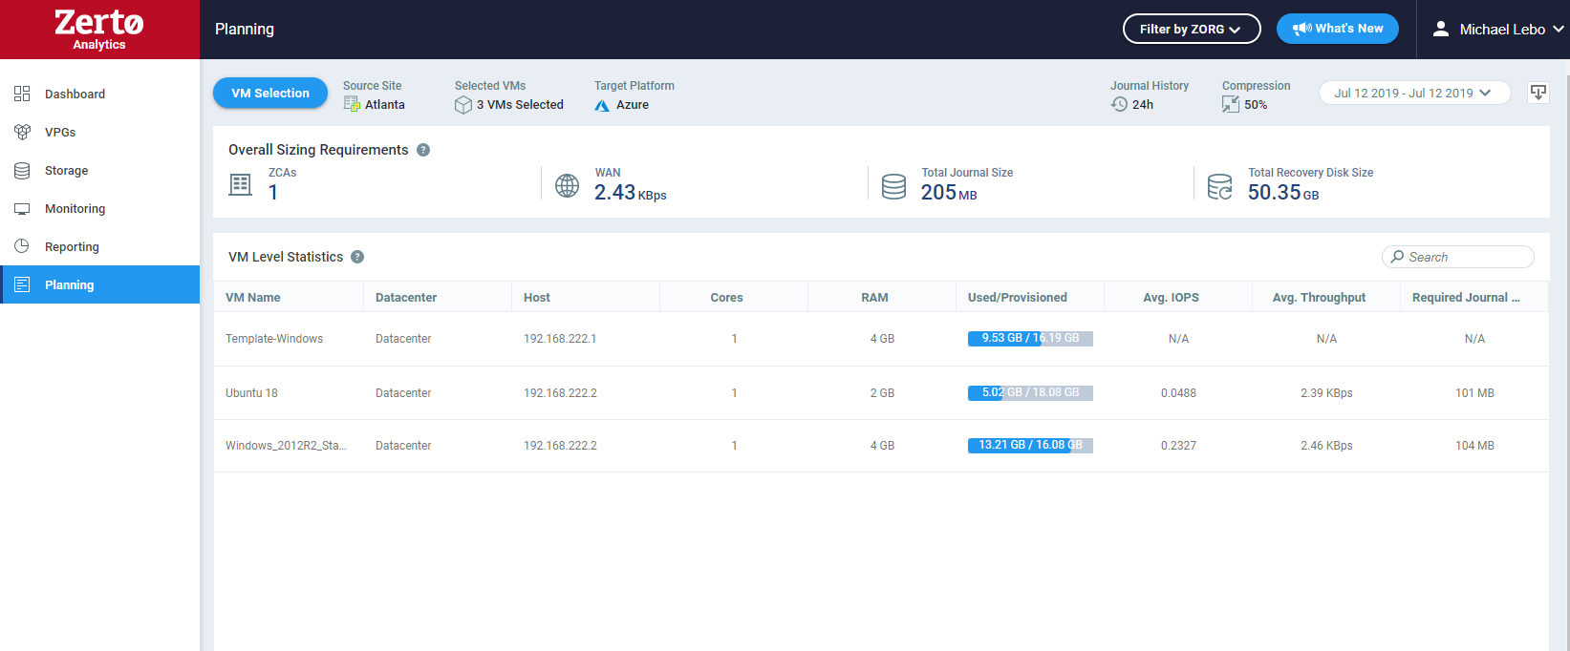

**Note:** On the top right-hand corner, there is a calendar timeline and an export option. The calendar allows you to select single or multiple days that the VMs have been monitored for to show the aggregate data for that timeframe. If needed, the export button allows you to export the data into a report for the customer’s own viewing.

Have questions or need assistance? Reach out to your Zerto account team or post in our [myZerto community support forums](https://www.zerto.com/myzerto/forums/forum/support-q-a/).